List of Certification for AI Assisted Coding

Certification#1
Title: Introduction to Git and GitHub
Link: https://infyspringboard.onwingspan.com/web/en/app/toc/lex_auth_014218482113093632326/overview
Duration: 20Hours
Marks: 3.0

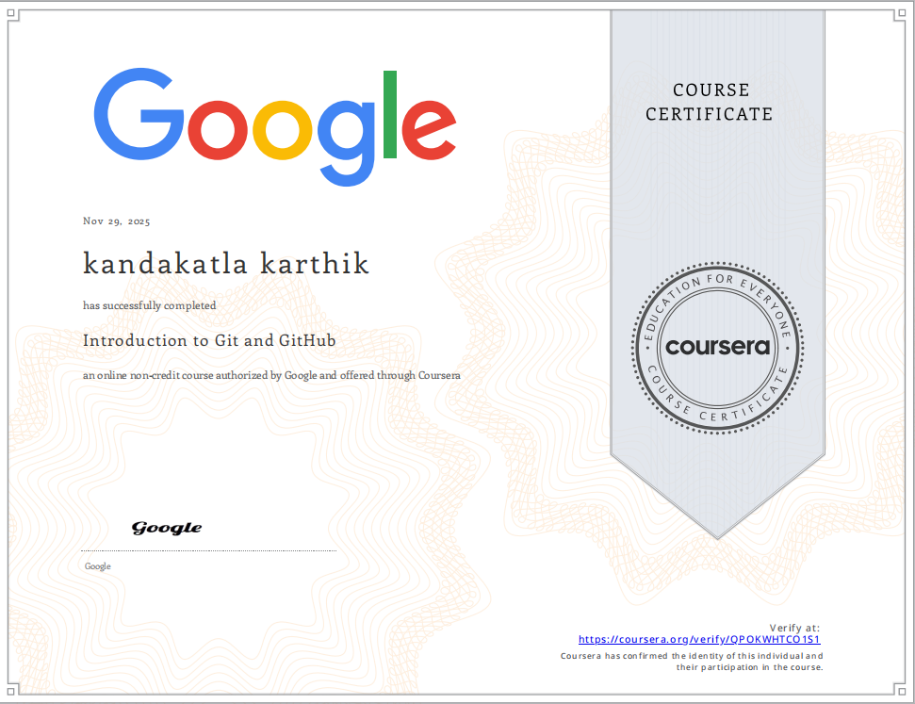

Certification#2
Title: Prompt Engineering
Link: c
Duration: 3 Hours
Marks: 0.5
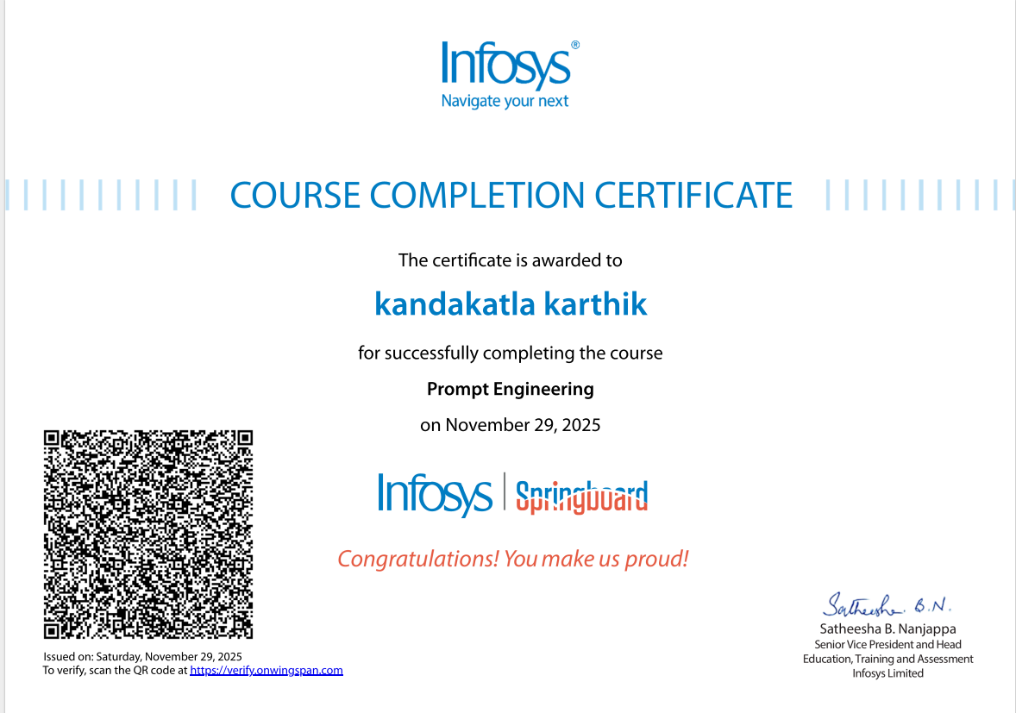

Certification#3
Title: GitHub Copilot for developers
Link: https://infyspringboard.onwingspan.com/web/en/app/toc/lex_auth_013749091701841920319_shared/overview
Duration: 7 Hours
Marks: 0.5
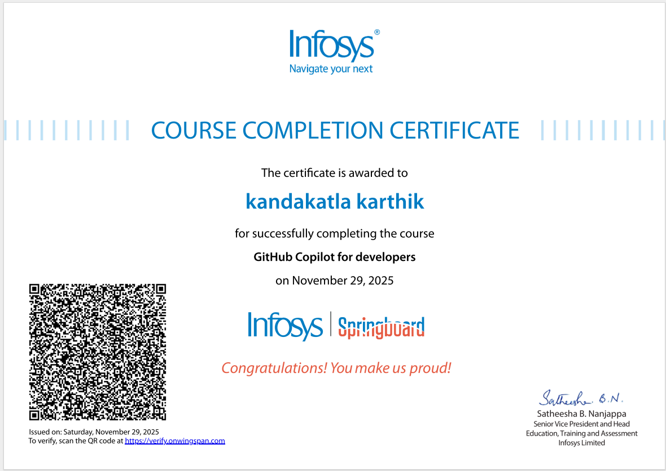

Certification#4
Title: Build Generative AI Apps and Solutions with No-Code Tools
Link: https://infyspringboard.onwingspan.com/web/en/app/toc/lex_auth_014157683688415232146/overview
Duration: 5 Hours
Marks: 0.5
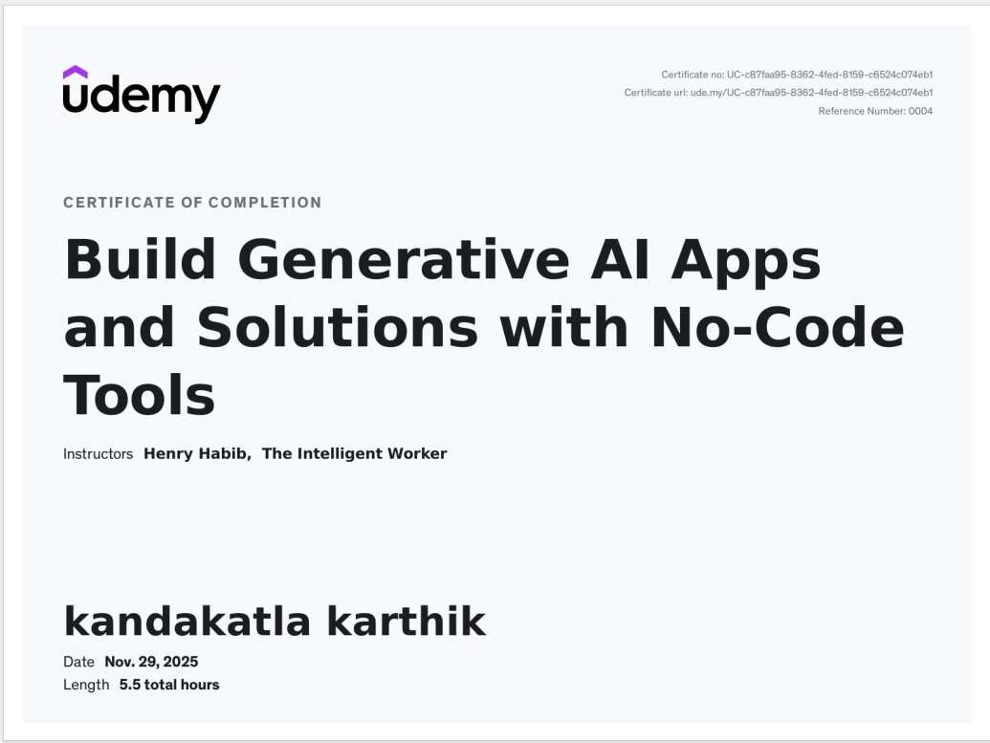

Certification#5
Title: GenAI for IT: Transforming IT with Generative AI
Link: https://infyspringboard.onwingspan.com/web/en/app/toc/lex_auth_014157698985598976246/overview
Duration: 6 Hours
Marks: 0.5
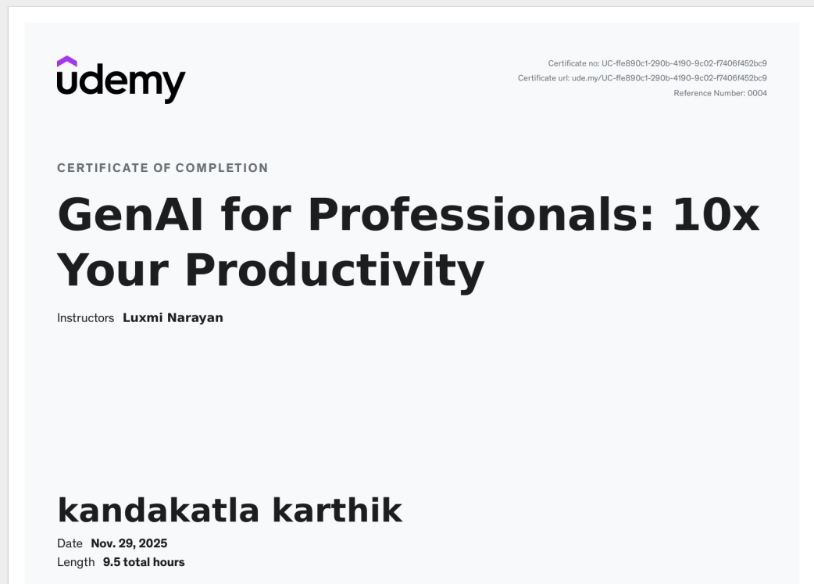

Certification#6
Title: Github Copilot with Python: Creating Text Games
Link: https://infyspringboard.onwingspan.com/web/en/app/toc/lex_auth_014222732610756608908/overview
Duration: 2 Hours
Marks: 0.5
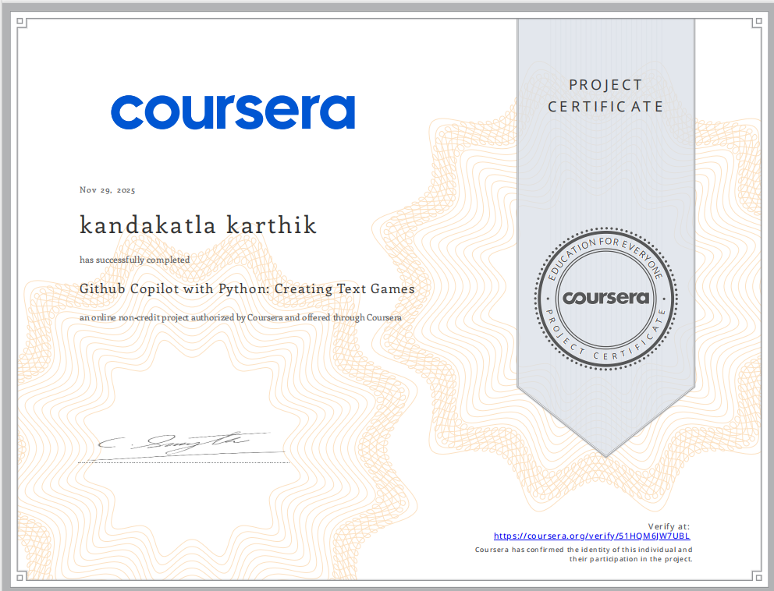

Certification#7
Title: Software Development with ChatGPT: Generating Code with AI
Link: https://infyspringboard.onwingspan.com/web/en/app/toc/lex_auth_0142227377610997761294/overview
Duration: 3 Hours
Marks: 0.5
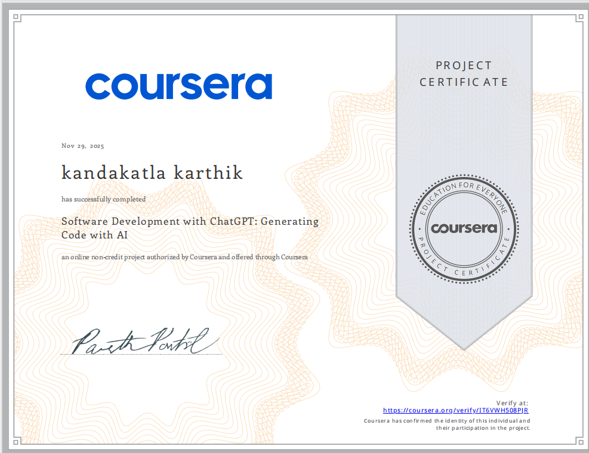

Certification#8
Title: Gen AI for developers: Web development with Python & Copilot
Link: https://infyspringboard.onwingspan.com/web/en/app/toc/lex_auth_0142354051890954242944/overview
Duration: 3 Hours
Marks: 0.5
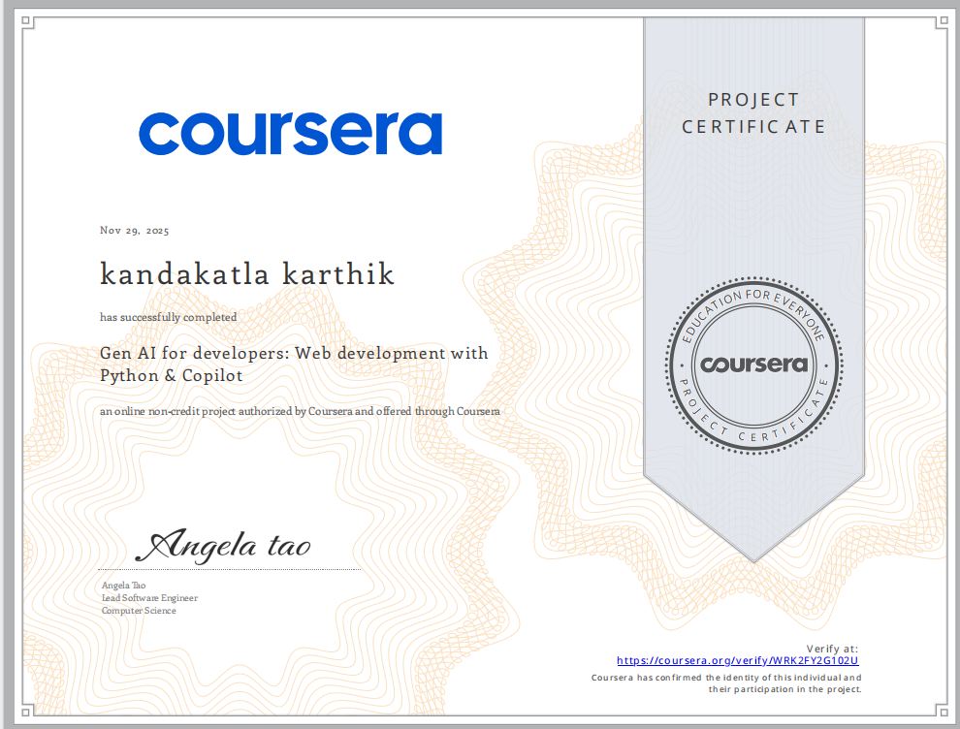

Certification#9
Title: Using JavaScript with AI: Enhancing Development Workflows
Link: https://infyspringboard.onwingspan.com/web/en/app/toc/lex_auth_014222738755936256945/overview
Duration: 3 Hours
Marks: 0.5
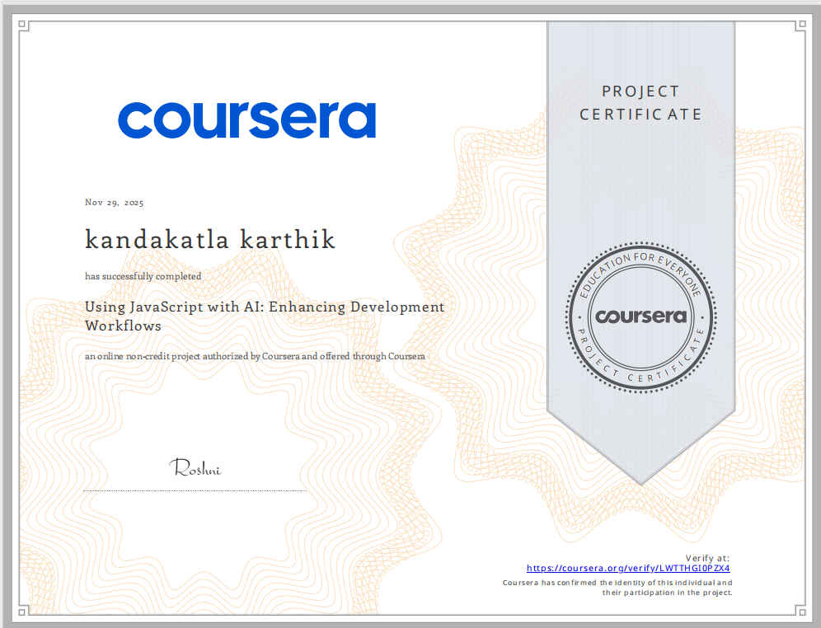

Certification#10
Title: Gen AI for Software Development: Code Generation for Python
Link: https://infyspringboard.onwingspan.com/web/en/app/toc/lex_auth_0142227476144947202012/overview
Duration: 3 Hours
Marks: 0.5
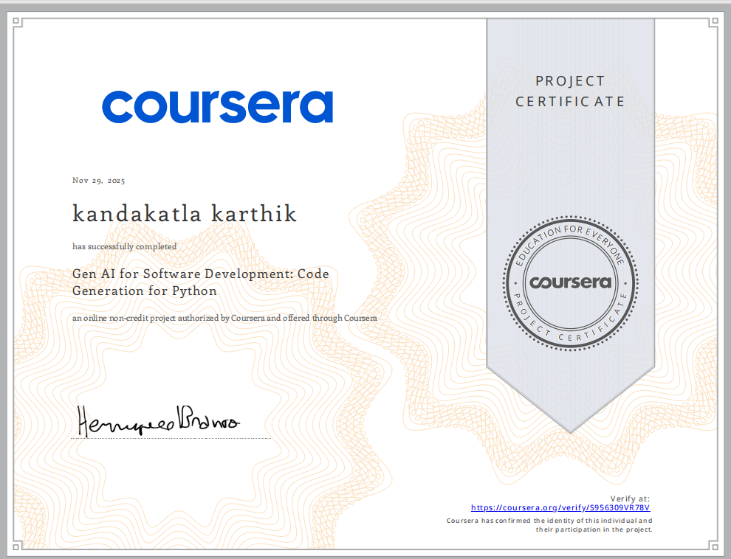

Certification#11
Title: Master Generative AI & Generative AI tools (ChatGPT & more)
Link: https://infyspringboard.onwingspan.com/web/en/app/toc/lex_auth_014157710267834368237/overview
Duration: 10 Hours
Marks: 1.5
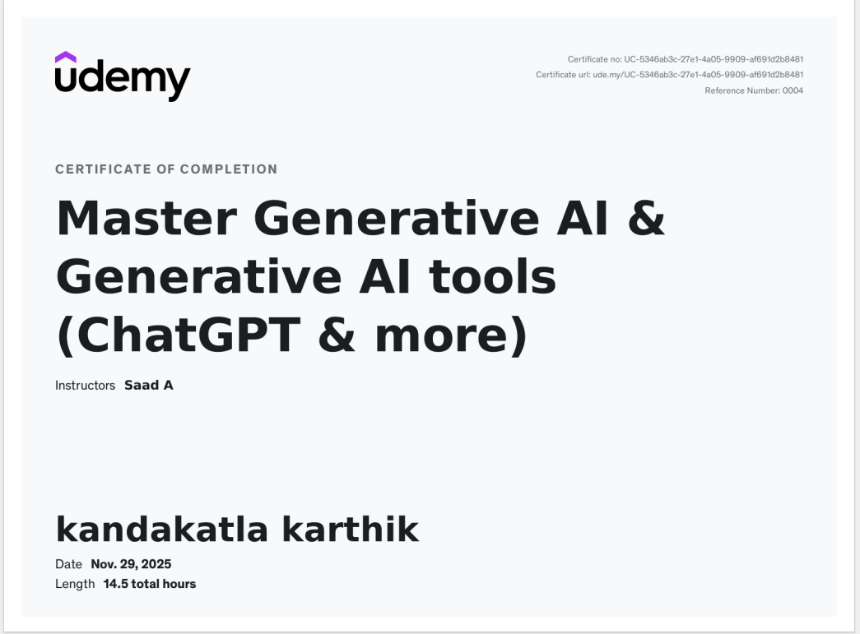

Certification#12
Title: Python Development with ChatGPT: Fullstack App Development
Link: https://infyspringboard.onwingspan.com/web/en/app/toc/lex_auth_0142227511742873602062/overview
Duration: 3 Hours
Marks: 0.5
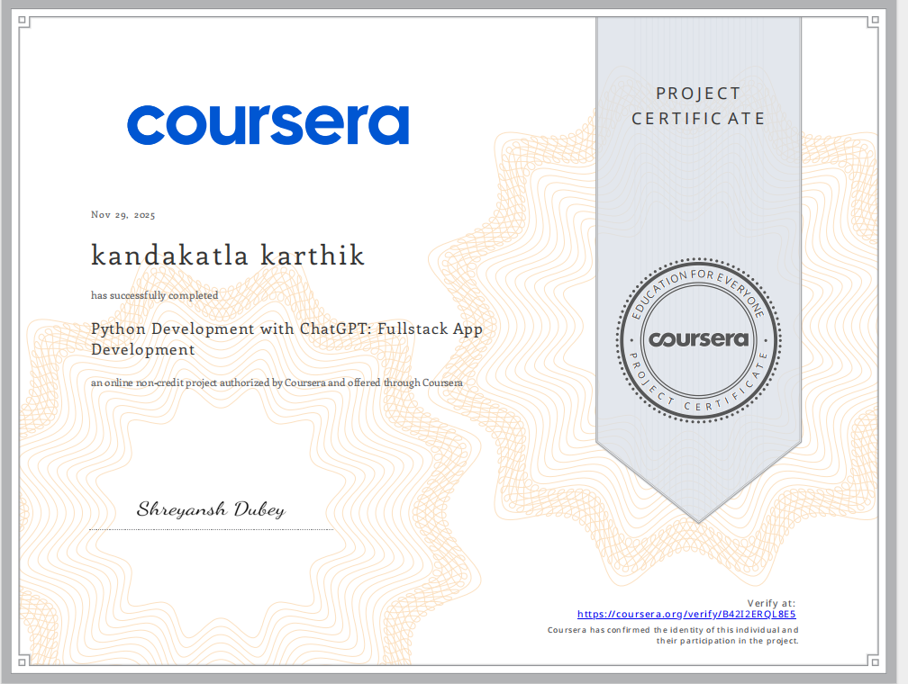

Certification#13
Title: PHP Development with ChatGPT: Practical Web Development
Link: https://infyspringboard.onwingspan.com/web/en/app/toc/lex_auth_0142354073538396162597/overview
Duration: 3 Hours
Marks: 0.5
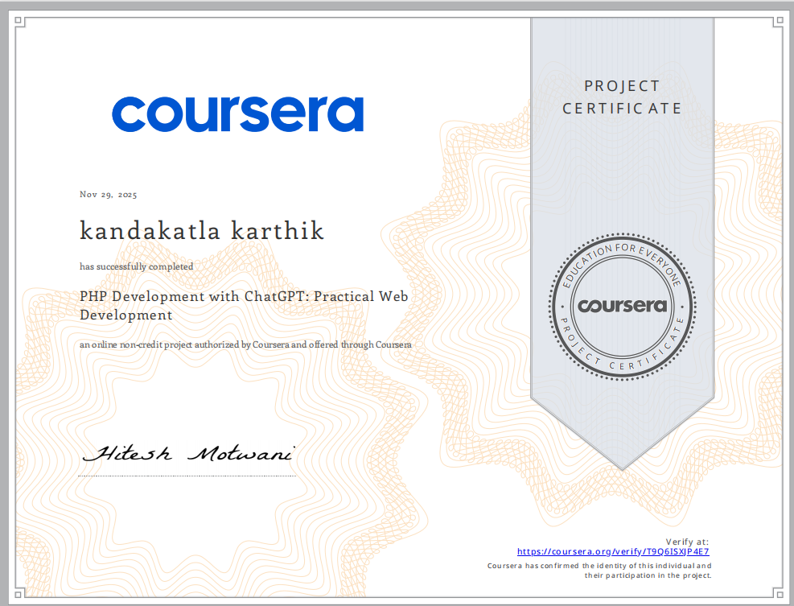

Certification#14
Title: AI-Powered Development with Codepal: Write & Test To-Do App
Link: https://infyspringboard.onwingspan.com/web/en/app/toc/lex_auth_0142354137550438403139/overview
Duration: 3 Hours
Marks: 0.5
